Partial / residual correlation: USDJPY and USDCAD
Method 07 / daily log returns / leave-currency-out USD factor / Alpari D1 full available history

Study setup
Logical pair: USDJPY , USDCAD
Broker symbols: USDJPY_i , USDCAD_i
Snapshot: 2026-11-03_majors_alpari_D1
Timeframe: D1
Matched return window: 1999-01-05 to 2026-11-02 (UTC bar dates)
Matched return count n: 7148
Dropped unfinished last bar dated 2026-11-03 UTC after a tick-volume check against the prior complete day.
USD-strength sign rule: minus log return when USD is the quote (EURUSD, GBPUSD, AUDUSD, NZDUSD); plus log return when USD is the base (USDJPY, USDCHF, USDCAD). EURGBP is never a constituent.
Control z constituents (5): EURUSD, GBPUSD, AUDUSD, NZDUSD, USDCHF
z_t = equal-weight mean of those USD-strength returns on the same day
Complete matched rows (Excel): USDJPY-USDCAD_Partial_D1.xlsx
Complete matched rows (HTML table): USDJPY-USDCAD_Partial_D1_data.html

Method carried forward
Partial / residual correlation regresses each matched daily log return of close, ln(close_t / close_t-1), on the same leave-currency-out USD strength factor z, then takes Pearson correlation of the two residual series. Quotes are not inverted. z is the equal-weight mean of USD-strength returns from other majors that do not share a non-USD currency with either leg; EURGBP is never a constituent. USD-strength is minus the log return when USD is the quote (EURUSD, GBPUSD, AUDUSD, NZDUSD) and plus the log return when USD is the base (USDJPY, USDCHF, USDCAD). OLS uses an intercept on each leg. rho_partial is symmetric under swap of the two symbols. It describes leftover linear co-movement after removing linear z; it is not a cause, not a lead, and not a trading signal. Daily rows are not independent and residuals are estimated, so the two-sided p-value and Fisher interval are secondary. Same-sample raw Pearson r is a side check only.

Regression on z
leg | intercept_a_or_c | slope_b_or_d | R2
USDJPY | 5.87e-05 | 0.30744685 | 0.07088925
USDCAD | -6.5e-07 | 0.59174058 | 0.38243054

Results
rho_partial: -0.182712
Two-sided p-value: 1.05709e-54
Approximate 95% Fisher interval: [-0.205027, -0.160208]
Same-sample raw Pearson r: 0.026249
rho_partial minus r: -0.208961

Conclusion
Over 7148 matched daily rows for USDJPY and USDCAD after removing a leave-currency-out USD factor built from 5 constituents, rho_partial is -0.1827 (negative, weak residual linear link in this sample). Approximate 95% Fisher interval: [-0.2050, -0.1602]. Same-sample raw Pearson r is 0.0262 (partial minus r = -0.2090). Leg R-squared on z: USDJPY=0.0709, USDCAD=0.3824. Two-sided p under the usual independent-pairs model is 1.057e-54; residuals are estimated and daily FX rows are linked, so treat p as secondary. This does not establish cause, lead-lag, or a lasting trading rule.

Charts
Daily closes
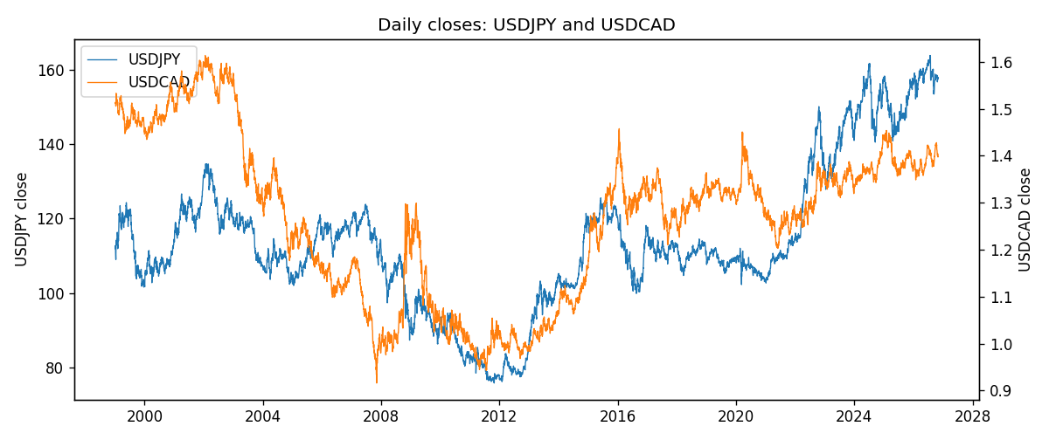
Log returns and control z
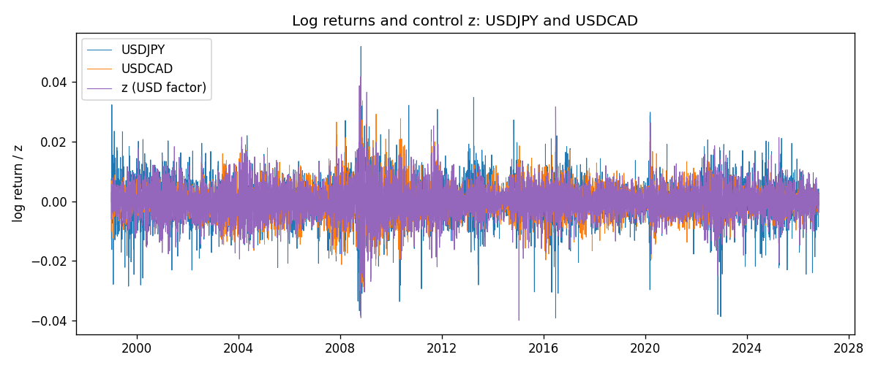
Residual scatter e_x vs e_y
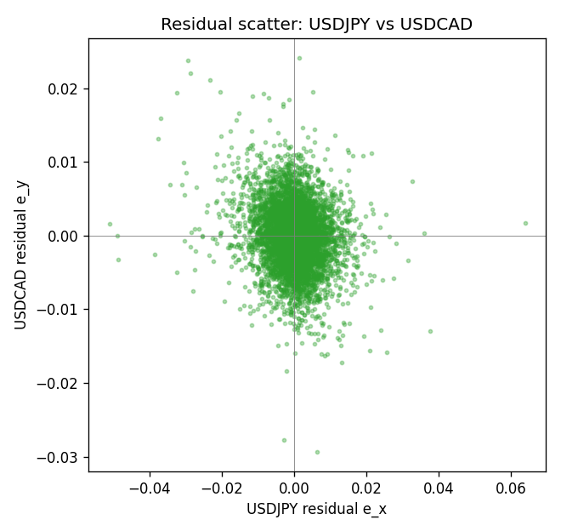

Data report
Every matched row that entered the partial correlation is stored in the sibling Excel workbook named USDJPY-USDCAD_Partial_D1.xlsx. That file is the complete data archive for redrawing charts. Embedding all rows as a Word table is impractical at this length; the Word file holds the column list, column summaries, and the first and last 15 matched rows.
Columns: time, USDJPY_open, USDCAD_open, USDJPY_high, USDCAD_high, USDJPY_low, USDCAD_low, USDJPY_close, USDCAD_close, USDJPY_tick_volume, USDCAD_tick_volume, USDJPY_spread, USDCAD_spread, USDJPY_real_volume, USDCAD_real_volume, USDJPY_log_return, USDCAD_log_return, usd_strength_EURUSD, usd_strength_GBPUSD, usd_strength_AUDUSD, usd_strength_NZDUSD, usd_strength_USDCHF, z, USDJPY_fitted, USDCAD_fitted, USDJPY_resid, USDCAD_resid
Column summaries (matched calculation rows)
column | count | mean | std | min | 25% | 50% | 75% | max
USDJPY_open | 7148 | 113.80278 | 19.266728 | 75.693 | 104.3275 | 110.969 | 120.725 | 163.824
USDCAD_open | 7148 | 1.2664001 | 0.16881677 | 0.9168 | 1.1174225 | 1.29842 | 1.3719025 | 1.6183
USDJPY_high | 7148 | 114.30008 | 19.328348 | 76.001 | 104.8345 | 111.426 | 121.27175 | 163.978
USDCAD_high | 7148 | 1.2712993 | 0.16876756 | 0.9336 | 1.1224 | 1.30385 | 1.3760825 | 1.619
USDJPY_low | 7148 | 113.28032 | 19.194266 | 75.402 | 103.8475 | 110.515 | 120.19 | 163.628
USDCAD_low | 7148 | 1.2618444 | 0.16884966 | 0.9056 | 1.1128375 | 1.29351 | 1.367575 | 1.6102
USDJPY_close | 7148 | 113.81631 | 19.281858 | 75.811 | 104.3175 | 110.995 | 120.7025 | 163.851
USDCAD_close | 7148 | 1.2664179 | 0.16878481 | 0.916 | 1.117435 | 1.298405 | 1.3722025 | 1.6137
USDJPY_tick_volume | 7148 | 106851.22 | 179762.89 | 197 | 10008.25 | 53482.5 | 93111.75 | 1803508
USDCAD_tick_volume | 7148 | 81445.79 | 147602.47 | 56 | 5642.25 | 41126 | 71764.5 | 1410818
USDJPY_spread | 7148 | 20.16704 | 17.582453 | 0 | 6 | 11 | 30 | 50
USDCAD_spread | 7148 | 23.322888 | 18.222444 | 0 | 9 | 17 | 40 | 60
USDJPY_real_volume | 7148 | 3.4953653e+10 | 1.6133327e+11 | 0 | 0 | 0 | 0 | 3.8834203e+12
USDCAD_real_volume | 7148 | 1.8476363e+10 | 9.6948735e+10 | 0 | 0 | 0 | 0 | 2.5751613e+12
USDJPY_log_return | 7148 | 5.267e-05 | 0.00620906 | -0.03908203 | -0.00319392 | 0.00012736 | 0.00340928 | 0.05184024
USDCAD_log_return | 7148 | -1.226e-05 | 0.00514518 | -0.03859748 | -0.00283513 | 4.873e-05 | 0.00272781 | 0.03436319
usd_strength_EURUSD | 7148 | 2.16e-06 | 0.0058013 | -0.03433183 | -0.00325609 | -0 | 0.00324218 | 0.03123819
usd_strength_GBPUSD | 7148 | 1.992e-05 | 0.00564699 | -0.03112653 | -0.00318167 | -3.426e-05 | 0.0031217 | 0.08388241
usd_strength_AUDUSD | 7148 | -3.157e-05 | 0.00755018 | -0.0806166 | -0.00415111 | -0.00029168 | 0.00385014 | 0.08602525
usd_strength_NZDUSD | 7148 | -1.914e-05 | 0.00764519 | -0.05966839 | -0.004586 | -0.00023666 | 0.00424201 | 0.07027433
usd_strength_USDCHF | 7148 | -6.945e-05 | 0.0065937 | -0.19545699 | -0.00334697 | 8.15e-05 | 0.00331954 | 0.09051364
z | 7148 | -1.962e-05 | 0.00537707 | -0.03988815 | -0.00308109 | -4.731e-05 | 0.0029984 | 0.04171657
USDJPY_fitted | 7148 | 5.267e-05 | 0.00165316 | -0.01220479 | -0.00088857 | 4.415e-05 | 0.00098055 | 0.01288432
USDCAD_fitted | 7148 | -1.226e-05 | 0.00318183 | -0.02360409 | -0.00182386 | -2.865e-05 | 0.00177362 | 0.02468473
USDJPY_resid | 7148 | -0 | 0.00598494 | -0.05106047 | -0.0029022 | 0.00012405 | 0.00300351 | 0.06377748
USDCAD_resid | 7148 | -0 | 0.00404337 | -0.02932447 | -0.00228156 | 2.92e-05 | 0.00226809 | 0.02413952
First 15 matched rows (selected columns)
time | USDJPY_close | USDCAD_close | USDJPY_log_return | USDCAD_log_return | z | USDJPY_fitted | USDCAD_fitted | USDJPY_resid | USDCAD_resid
1999-01-05 | 111.92 | 1.5123 | -0.00017868311 | -0.010131666 | 0.0028678218 | 0.0009403997 | 0.0016963534 | -0.0011190828 | -0.011828019
1999-01-06 | 112.77 | 1.5118 | 0.0075660159 | -0.0003306769 | 0.0023752457 | 0.00078895874 | 0.0014048762 | 0.0067770571 | -0.0017355531
1999-01-07 | 111.33 | 1.5141 | -0.012851583 | 0.0015202092 | -0.0060118163 | -0.0017896171 | -0.0035580887 | -0.011061965 | 0.0050782979
1999-01-08 | 110.8 | 1.511 | -0.0047719894 | -0.0020495197 | 0.0056154586 | 0.001785152 | 0.0033222416 | -0.0065571414 | -0.0053717613
1999-01-11 | 109.02 | 1.5057 | -0.016195423 | -0.0035137769 | 0.00011458654 | 9.3926184e-05 | 6.7152381e-05 | -0.016289349 | -0.0035809293
1999-01-12 | 112.6 | 1.5157 | 0.032310364 | 0.0066194721 | -0.0012854071 | -0.00033649747 | -0.00076128069 | 0.032646862 | 0.0073807528
1999-01-13 | 113.52 | 1.5226 | 0.0081373171 | 0.0045420214 | -0.0040747306 | -0.0011940662 | -0.0024118366 | 0.0093313833 | 0.006953858
1999-01-14 | 113.52 | 1.5332 | 0 | 0.0069376546 | -0.00029614737 | -3.2352665e-05 | -0.00017589554 | 3.2352665e-05 | 0.0071135502
1999-01-15 | 114.15 | 1.5245 | 0.0055343401 | -0.0056905671 | 0.0046942373 | 0.0015019254 | 0.0027771176 | 0.0040324147 | -0.0084676846
1999-01-18 | 114.16 | 1.526 | 8.7600193e-05 | 0.00098344542 | -0.0014217449 | -0.00037841408 | -0.00084195727 | 0.00046601427 | 0.0018254027
1999-01-19 | 113.52 | 1.5302 | -0.0056219403 | 0.002748513 | -0.0021713963 | -0.00060889205 | -0.0012855564 | -0.0050130483 | 0.0040340694
1999-01-20 | 112.91 | 1.5211 | -0.0053879917 | -0.0059646885 | 0.0019990295 | 0.00067329224 | 0.0011822538 | -0.0060612839 | -0.0071469422
1999-01-21 | 113.87 | 1.5146 | 0.0084664056 | -0.0042823796 | -0.0029680899 | -0.00085383297 | -0.0017569923 | 0.0093202386 | -0.0025253873
1999-01-22 | 114.56 | 1.5184 | 0.0060412564 | 0.0025057712 | 0.0045778457 | 0.0014661412 | 0.002708244 | 0.0045751152 | -0.00020247278
1999-01-25 | 113.72 | 1.5197 | -0.0073594164 | 0.00085579808 | 0.0023565632 | 0.00078321484 | 0.0013938209 | -0.0081426313 | -0.00053802284
Last 15 matched rows (selected columns)
time | USDJPY_close | USDCAD_close | USDJPY_log_return | USDCAD_log_return | z | USDJPY_fitted | USDCAD_fitted | USDJPY_resid | USDCAD_resid
2026-10-13 | 158.305 | 1.4214 | -0.0018932826 | -0.0046395653 | -0.0036225355 | -0.0010550402 | -0.0021442543 | -0.00083824236 | -0.0024953109
2026-10-14 | 158.317 | 1.42356 | 7.5800166e-05 | 0.0015184751 | 0.0033726991 | 0.0010956226 | 0.0019951098 | -0.0010198225 | -0.00047663473
2026-10-15 | 158.024 | 1.41843 | -0.0018524319 | -0.0036101503 | -0.0038414526 | -0.0011223456 | -0.0022737965 | -0.00073008632 | -0.0013363538
2026-10-16 | 157.964 | 1.41357 | -0.00037976126 | -0.0034322068 | -0.0036591036 | -0.001066283 | -0.0021658932 | 0.00068652171 | -0.0012663136
2026-10-19 | 158.517 | 1.41091 | 0.0034946841 | -0.0018835331 | 0.00018939215 | 0.00011692493 | 0.0001114179 | 0.0033777592 | -0.001994951
2026-10-20 | 158.16 | 1.40569 | -0.0022546642 | -0.0037066008 | -0.0035581221 | -0.0010352365 | -0.0021061384 | -0.0012194277 | -0.0016004625
2026-10-21 | 158.108 | 1.4045 | -0.00032883504 | -0.00084691787 | -0.0016052823 | -0.00043484207 | -0.00095056377 | 0.00010600702 | 0.0001036459
2026-10-22 | 156.755 | 1.40081 | -0.0085942669 | -0.0026307268 | 0.00022762804 | 0.00012868044 | 0.00013404362 | -0.0087229473 | -0.0027647704
2026-10-23 | 156.81 | 1.40085 | 0.00035080446 | 2.85545e-05 | 0.00072723582 | 0.00028228328 | 0.00042968182 | 6.8521187e-05 | -0.00040112732
2026-10-26 | 157.458 | 1.40093 | 0.0041238746 | 5.7106554e-05 | 0.0025296388 | 0.0008364264 | 0.0014962368 | 0.0032874482 | -0.0014391302
2026-10-27 | 157.894 | 1.40449 | 0.0027651658 | 0.0025379458 | 0.001544849 | 0.00053365586 | 0.00091349669 | 0.0022315099 | 0.0016244491
2026-10-28 | 157.743 | 1.39911 | -0.00095679538 | -0.0038379274 | 0.00016383054 | 0.0001090661 | 9.6292058e-05 | -0.0010658615 | -0.0039342194
2026-10-29 | 157.683 | 1.39895 | -0.00038043789 | -0.00011436495 | -0.0014487396 | -0.00038671352 | -0.00085793114 | 6.2756321e-06 | 0.00074356618
2026-10-30 | 157.516 | 1.39751 | -0.0010596481 | -0.0010298736 | -0.00013777691 | 1.6337837e-05 | -8.2181309e-05 | -0.001075986 | -0.00094769226
2026-11-02 | 157.933 | 1.39837 | 0.0026438521 | 0.00061519094 | -0.000569775 | -0.00011647862 | -0.00033781211 | 0.0027603307 | 0.00095300305

